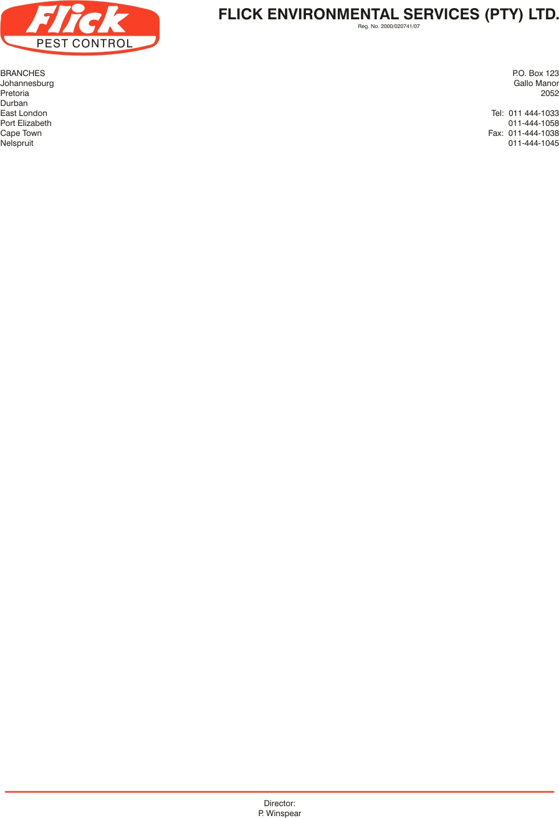
Invoice to: Ice Cream Company, PO Box 2301, Bromhof, 2154

VAT no:

Contact person: George Selipas 0117910637 / 3759 / 6940. Fax 0117917035 / george_s@icecreamco.co.za
0824174372

Service address: 187 Arbeid Avenue, Strydom Park

SERVICE AGREEMENT NO 12655

- FLICK PEST CONTROL agrees to carry out inspections and treatments at the addresses noted above to bring under control any infestation by rats, mice, cockroaches
in the following areas: Servicing of the entire premises throughout for cockroaches and rodents, including offices, bathrooms, kitchen, store, factory and refuse area
18 Rodent bait stations around the outside of the warehouses to be treated on a monthly basis

- FLICK PEST CONTROL agrees to carry out such further inspections and treatments as may be necessary to maintain control of these pests on these premises. Services will be done on a monthly cycle to maintain control of the above pests. (Minimum of 12 treatments and inspections per annum)

- In the event of re-infestation by specified pests anytime during the life of the agreement, FLICK PEST CONTROL will make additional inspections and treatments as to re-establish control of the pests at no extra charge to the client.

- The client agrees to pay for these services at the rate of R 780.00 (Exc. VAT) for the initial service. Thereafter R780.00 (Exc. VAT) monthly. The first payment is due on the commencement of the agreement and the subsequent payments monthly thereafter. This price is subject to inflationary increases which take effect periodically.

- This agreement is binding for one year from this date. Notice in writing is required to terminate the agreement at the end of the fist year, or thereafter 3 months notice.

Signed this 7th day of May 2013

Client signature: ________________________ For Flick: _______________________
Client name: Paul Sanet Haupt

